SMART HOME AUTOMATION

RAJESWARI .S- 962719104029

BATCH : B9-3A5E

CODE:

int t=2; int e=3;

void setup()

{

Serial.begin(9600);

pinMode(t,OUTPUT);

pinMode(e,INPUT);

pinMode(12,OUTPUT);

}

void loop()

{

//ultrasonic sensor

digitalWrite(t,LOW);

digitalWrite(t,HIGH);

delayMicroseconds(10);

digitalWrite(t,LOW); float

dur=pulseIn(e,HIGH); float

dis=(dur*0.0343)/2;

Serial.print("Distance is: ");

Serial.println(dis);

//LED ON if(dis>=100)

{

delay(1000);

**//LED ON if(t>=100)**

{

digitalWrite(8,HIGH);

digitalWrite(7,HIGH);

}

**//Buzzer for Temperature Sensor if(t>=100)**

{

for(int i=0; i<=30000; i=i+10)

{

**tone(12,i);**

**delay(1000);**

**noTone(12);**

**delay(1000);**

**}**

**}**

**//LED OFF if(t<100)**

{

**digitalWrite(8,LOW);**

**digitalWrite(7,LOW);**

}

**}**

**CIRCUIT DIAGRAM**

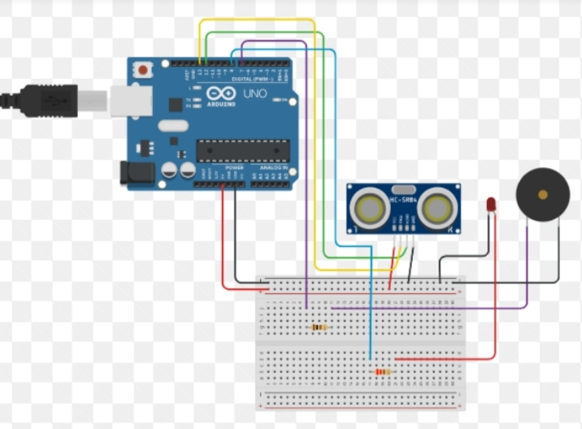

**TINKERCAD LINK**

**https://www.tinkercad.com/things/j6yUWg48EIL**